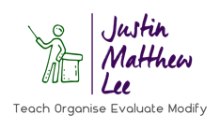
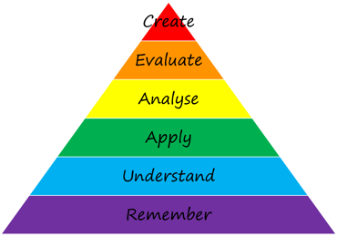

Guided Reading Bloom’s Taxonomy Questions, Activities or Discussion Points
Band/Level and Book Title
Remembering

Understanding

Applying

Analysing

Evaluating

Creating

